 | João Eurico de Aguiar Lima |  |  |  |  |  |  |  | 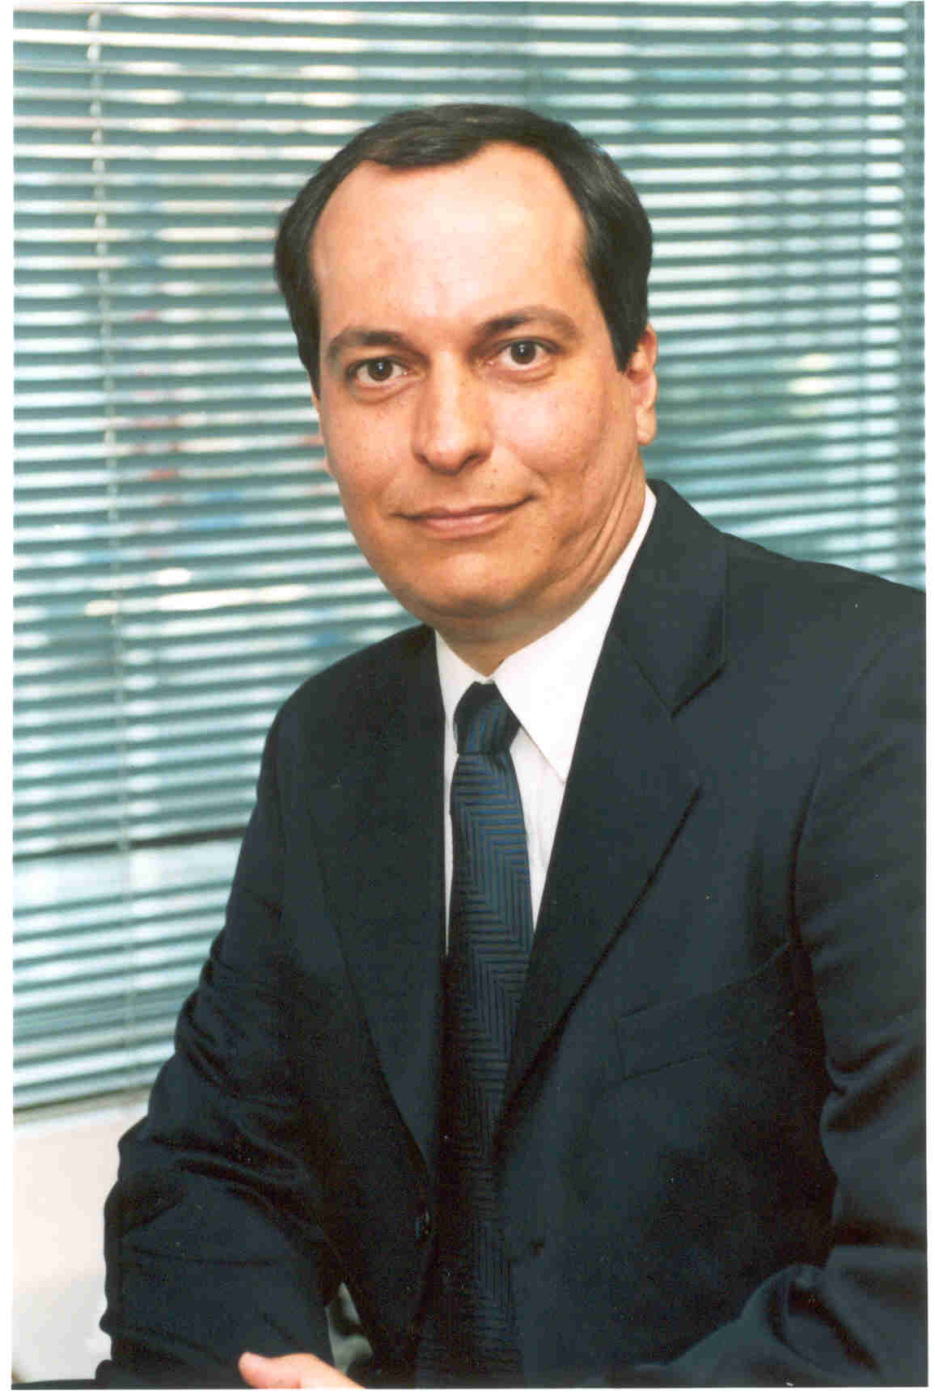
 | 48 years old - Brazilian – Married
 | Home Adrress  Rua Viscondessa do Livramento, 174  Derby – Recife – Brazil  CEP 52010-060  joao.eurico@live.com |  |  |  |  |  | Home phone # 55-81-3034-5466  Mobile # 55-81-9476-3259
 | _{OBJECTIVES}
 | • Management position in Sales Department
 | _{QUALIFICATIONS}
• Extensive experience in Sales team management
• Extensive knowledge of Sales processes and techniques.
• Full domain of the order-to-delivery cycle for software and IT products and services
• Strong leadership and experience with coaching of Sales professionals.
• Proven track record with results exceeding sales goals.
•Teamwork, comunications and social skills.
 |  | Carl Zeiss Brazil
 |  | World Leader in microscopy
 |  | Regional Sales Manager – December 2012 – present
- Pre Sales activities
- Product demonstration and specfication
- Sales team trainning and development
- Management of sales channel partners
- Branch office management
- Participation in the full Sales cycle, either as head of the team or as consultant
- Sales of advanced microscopy products such as electron microscopes, laser scanning microscopes
- Public and private sector
- Sales Quota and commission management
- Influence and participation in public tender bids

 |  | Procenge
 |  | Software House, ERP vendor
 |  | Product Consultant – June/05 thru november/2012
- Pre Sales activities
- Product demonstration and specfication
- Sales team trainning and development
- Designer of partnership with other companies
- Specialized assistance to Human Resource department when hiring new personel for sales force
- Participation in the full Sales cycle, either is head of the team or as consultant
- Sales of ERP, CRM, MRP products and services
- Participation in public tenders

 |  | Elógica |  |  |  |  |  | Feb/04 to Mar/05
 |  | Software House, internet service provider
 |  | Director of Marketing and Sales – Fev/04 a march/05
- Setup of São Paulo office
- Recruiting of Sales team for São Paulo and Olinda offices
- Strategic planning of Sales effort throughout entire corporation
- Trainnee program development
- Sales cycle coordination
- Sales of ISP services, digital printing Office, Sales automation solutions for retail sector
- Sales and distribution channel administration and expansion

 |  | Director of Human Resources Unit – Jan/05 a Mar/05
- Planning for whole unit
- Creation and coordination of Sales team for specific business unit
- Product evaluation and life cycle management

 |  | Sena Informática |  |  |  |  |  | Jun/03 to Jan/04
 |  | Software integrator, value added reseller of Oracle, IBM and Sun
 |  | Recife Branch Manager – Jun/03 to Jan/04
- Setup of Recife branch office
- Hiring of local personel, including Sales team
- Sales process management
- Contract renegotation

 |  | Fastbee do Brasil |  |  |  |  |  | Jun/02 to Jun/03
 |  | Multinational ISP with headquarters in USA
 |  | Director of operations / Corporate representative - Aug/02 to jun/03
 |  | - Responsible for whole operations, including provisioning, operations, customer care
 |  | Manager of operations – Jun/02 to aug/02
- Supervision of whole operation in Argentina, Mexico, Panama and Brasil
- Hiring of operational personnel

 |  | Intersight |  |  |  |  |  | Dec/01 to Jun/02
 |  | Value added reseller for IBM/Lotus, Trend Micro, Enterasys
 |  | Large accounts manager - Dec/01 a Jun/02
 |  | Inter.Net |  |  |  |  |  | Jul/00 to Jul/01
 |  | Multinational ISP with HQ in USA
 |  | IT Director - Sep/00 to Jul/01
 |  | Business Development Manager - Jul/00 to Aug/00
 |  | Connect SI (Now Getronics) |  |  |  |  | Jan/00 to Mai/00
 |  | System Integrator and outsource provider
 |  | Recife Branch Manager - Jan/00 to May/00
 |  | Terasoft |  |  |  |  | Jan/92 to Jul/98
 |  | Software vendor
 |  | Sales and Marketing Director (Partner) - Jan/92 to Jul/98
• Setup of Sales team
Sales team hiring and trainning
Complete cycle of sales management.
 | _{Languages}
 |  |  |  | Spanish – Advanced
 |  |  |  | Inglês – Fluency
 | _{Formal Education}
BS in Computer Science 1989 – UFPE – Brazil
Business Degree in Finance – In course

